
SMART EXPENSE TRACKER AND GOAL BASED SAVING ANALYZER
SASANK.T – 23619233
VIGNESH KUMAR.S. R - 23619259
VENKATA ANIL.P - 23619222
VELS INSTITUTE OF SCIENCE, TECHNOLOGY & ADVANCED STUDIES
(VISTAS)
MINI PROJECT REPORT
Submitted to the
SCHOOL OF ENGINEERING
DEPARTMENT OF ARTIFICIAL INTELLIGANCE AND MACHINE LEARNING
in Partial fulfilment of the requirements for the award of the degree of
BACHELOR OF TECHNOLOGY
IN
ARTIFICIAL INTELLIGENCE AND MACHINE LEARNING
VELS INSTITUTE OF SCIENCE, TECHNOLOGY AND ADVANCED STUDIES (VISTAS)
CHENNAI – 600 117
OCTOBER 2026

BONAFIDE CERTIFICATE

Certified that this project report “SMART EXPENSE TRACKER AND GOAL BASED SAVING ANALYZER”, is the Bonafide work of T. SASANK - 23619233, S.R. VIGNESH KUMAR - 23619259, P. VENKATA ANIL - 23619222 carried out the project under my supervision. Certified further, that to the best of my knowledge the work reported here does not form part of any other project report or dissertation on the basis of which a degree or award was conferred on an earlier occasion on this or any other candidate

SIGNATURE OF THE HOD SIGNATURE OF THE SUPERVIOR
Dr. K. Ulaga Priya M.E., Ph.D. MS.P. SHANTHI M.E
Associate Professor & Head Assistant Professor
Of the Department AI&ML Department of AI&ML
School of Engineering School of Engineering
VISTAS VISTAS
Chennai Chennai

Submitted for the Project Work and Viva - Voce examination held on……………
at Vels Institute of Science, Technology and Advanced Studies (VISTAS), Chennai – 600 117.

INTERNAL EXAMINER EXTERNAL EXAMINER

ACKNOWLEDGEMENT

It is certainly a great delight and proud privilege to acknowledge the help and support I received from the positive minds around me in making this venture a successful one. The infrastructural support with all kinds of lab facilities have been a motivating factor in this completion of project work, all because of FOUNDER & CHAIRMAN, Shri. Dr. ISHARI K. GANESH., with great pleasure that I take this opportunity to thank him. I am grateful to our HEAD OF THE DEPARTMENT, Dr. K. Dr. Ulaga Priya, for her continuous support for the project, from initial advice and contacts in the early stages of conceptual inception, and through on-going advice and encouragement to this day. I extend our warmest thanks to my INTERNAL GUIDE, MS.P. SHANTHI Assistant Professor /AI&ML, who has patiently guided and provided us with invaluable advice and help. I would like to express my greatest gratitude to our Staff members, Librarian, and Non-teaching staff members of Computer Centre, who have helped and supported me throughout. Last but not the Least, I wish to thank my parents and my friends for their individual support and interest who has inspired me and encouraged me to go in my own way, without them I would be unable to complete this project.

SASANK.T- 23619233
VIGNESH KUMAR.S. R- 23619259
VENKATA ANIL.P - 23619222

CHAPTER NO. | TABLE OF CONTENT | PAGE NO
 | ABSTRACT | 5
1 | INTRODUCTION | 7
 | 1.1 Overview of the project | 7
 | 1.2 Scope and objective | 8
 | 1.3 system overview | 10
2 | LITERATURE REVIEW | 19
 | 2.1 Literature Overview | 19
 | 2.2 Literature Survey | 20
3 | SYSTEM DESIGN | 21
 | 3.1 Existing System | 21
 | 3.2 Proposed System | 21
 | 3.3 System Architecture | 22
 | 3.4 Hardware Requirements | 24
 | 3.5 Software Requirements | 25
4 | IMPLEMENTATION | 27
 | 4.1 Methodology | 27
 | 4.2 Research approach | 28
 | 4.3 implementation | 28
5 | CONCLUSION AND FUTURE WORK | 29
 | 5.1 Conclusion | 29
 | 5.2 Purpose and Achievements | 29
 | 5.3 Technical highlights | 32
 | 5.4 Results | 34
 | REFERENCES | 36

ABSTRACT

The Smart Expense Tracker and Goal-Based Saving Analyzer is an AI-powered personal finance management system designed to help users monitor their income, expenses, and savings efficiently. The system allows users to record and manage financial transactions, categorize expenses, set savings goals, and track their progress through an interactive dashboard. It uses a Flask-based backend and a MySQL database to process and store user information, transaction records, and savings details securely.
The system incorporates Artificial Intelligence and Machine Learning techniques to analyse spending patterns, predict future expenses, identify unnecessary spending, and provide personalized savings recommendations. It also monitors progress toward financial goals and helps users adjust their savings plans when they miss their targets. Graphical representations, including bar charts, doughnut charts, line charts, and progress indicators, enable users to understand their financial activities easily. Notifications and alerts provide updates about spending limits, savings progress, and recommended financial adjustments. Overall, the proposed system aims to improve financial awareness, encourage disciplined spending habits, and support effective goal-oriented saving through intelligent analysis and visualization.
Furthermore, the proposed system provides a user-friendly and structured approach to personal financial planning by combining transaction management, data analysis, and goal-based savings in a single platform. It helps users understand their spending behaviour, compare monthly financial activities, and make informed decisions about their budgets. The system can be further enhanced by integrating real-time payment applications, automated transaction tracking, advanced prediction models, and personalized financial planning features. These improvements can make the application more effective, reliable, and adaptable to individual financial needs. Thus, the Smart Expense Tracker and Goal-Based Saving Analyzer serves as a practical solution for promoting better money management and achieving long-term financial goals.

S.NO | ABBREVATION | FULL FORM
1. | UI | USER INTERFACE
2. | UX | USER EXPERIENCE
3. | DB | DATA BASE
4. | SQL | STRUCTURED QUERY LANGUAGE
5. | HTML | HYPER TEXT MARKUP LANGUAGE
6. | JS | JAVA SCRIPT
7. | API | APPLICATION PROGRAMMING INTERFACE
8. | HTTP | HYPER TEXT TRANSFER PROTOCOL
9. | CRUD | CREATE, READ, UPDATE, DELETE
CHAPTER 1. INTRODUCTION

OVERVIEW OF THE PROJECT

Introduction
In today's digital world, managing personal finances has become increasingly important. Many people face difficulties in tracking daily expenses, controlling unnecessary spending, and achieving their savings goals. Smart Expense Tracker and Goal-Based Savings Analyzer is an AI-based personal finance application designed to simplify financial management. It enables users to track income and expenses, categorize transactions, monitor spending patterns, and visualize financial activities through interactive dashboards and charts.
The application integrates Artificial Intelligence (AI) and Machine Learning (ML) to analyse historical spending data and predict future expenses. It provides personalized spending recommendations, budget alerts, and goal-based savings tracking to help users achieve their financial targets within a specified period. Developed using Flutter, Python Flask, Firebase/MySQL, Pandas, NumPy, and Scikit-learn, Smart Spend combines AI and financial technology to improve financial awareness, encourage regular saving habits, reduce unnecessary expenses, and support better financial decision-making.

Problem Statement
The primary target users of Smart Expense Tracker and Goal-Based Savings Analyzer are college students, salaried employees, young professionals, and individuals who want to manage their personal finances effectively. It is particularly useful for users with limited budgeting experience who need help tracking daily expenses, controlling unnecessary spending, and developing regular saving habits. The application also benefits individuals who want to set financial goals, monitor savings progress, predict future expenses, and receive personalized recommendations to improve their financial management.

Objectives of the Project
The main objectives of this project are:
- Expense Tracking: To develop an application that records, categorizes, and monitors users' income and expenses efficiently.
- AI-Based Expense Prediction: To analyse historical spending patterns and predict future expenses using machine learning techniques.
- Budget and Savings Management: To help users set budgets, establish savings goals, track progress, and receive alerts when spending exceeds planned limits.
- Personalized Financial Insights: To provide intelligent recommendations for reducing unnecessary expenses, improving saving habits, and achieving financial goals.
1.2 Scope and Highlights:
- Income and Expense Management: Records, categorizes, and tracks daily financial transactions.
- AI-Based Expense Prediction: Analyses spending patterns and predicts future expenses using machine learning.
- Smart Budget Alerts: Notifies users when their spending exceeds predefined budget limits.
- Goal-Based Savings: Helps users set savings targets, monitor progress, and calculate the required savings amount.
- Personalized Recommendations: Suggests ways to reduce unnecessary expenses and improve saving habits.
- Interactive Dashboard: Displays income, expenses, savings, and spending patterns through charts and graphs.
- Financial Insights: Provides data-driven insights to support better personal financial decisions.
1.3 SCOPE AND OBJECTIVES
The system integrates three major components:
- User Interface: Provides a user-friendly interface using Flutter to manage income, expenses, budgets, and savings goals.
- Transaction Management: Records, categorizes, and stores users' income and expense transactions in Firebase/MySQL.
- Backend Processing: Uses Python Flask to process user requests, manage transactions, and connect the frontend with the database.
- AI-Based Analysis: Uses Pandas, NumPy, and Scikit-learn to analyse spending patterns and predict future expenses.
- Budget Alerts: Notifies users when their spending exceeds predefined budget limits.
- Goal-Based Savings: Tracks savings progress and calculates the amount required to achieve financial goals within a specified period.
- Interactive Dashboard: Displays income, expenses, savings, and financial insights through charts and graphs.
Advantages of the System
- Automated Expense Tracking: Simplifies recording and categorizing income and expenses.
- Accurate Expense Prediction: Uses machine learning to predict future expenses based on historical spending patterns.
- Improved Budget Management: Helps users control spending through budget monitoring and alerts.
- Goal-Based Savings: Enables users to set financial targets and track their savings progress.
- Personalized Recommendations: Suggests ways to reduce unnecessary expenses and improve saving habits.
- Visual Financial Analysis: Provides interactive charts and graphs for easy understanding of financial activities.
- Better Financial Decisions: Helps users manage money efficiently through data-driven insights.
Applications of the Project
- Personal Finance Management: Helps individuals track income, expenses, and monthly budgets.
- Monthly Budget Planning: Helps salaried employees plan monthly expenses and monitor spending limits.
- Goal-Based Savings Planning: Supports users in setting savings targets and tracking progress toward financial goals.
- Future Expense Prediction: Uses machine learning to estimate upcoming expenses based on historical spending data.
- Spending Pattern Analysis: Identifies unnecessary spending and provides personalized recommendations.
- Financial Awareness: Encourages better money management and disciplined saving habits through AI-powered insights.
Expected Outcomes
At the end of this project, the expected outcomes include:
- Efficient Expense Tracking: Enables users to record, categorize, and monitor income and expenses in one application.
- Expense Prediction: Predicts future spending patterns using machine learning techniques.
- Improved Budget Control: Provides budget alerts to help users avoid unnecessary spending and manage expenses effectively.
- Savings Goal Achievement: Tracks savings progress and calculates the amount required to achieve financial goals within a specified period.
- Personalized Financial Insights: Generates AI-based recommendations to improve spending habits and savings.
- Interactive Financial Dashboard: Displays income, expenses, savings, and spending trends through charts and graphs.
- Better Financial Management: Helps users make informed financial decisions, develop disciplined saving habits, and improve overall financial awareness.
Future Enhancements
Future versions of this system could include:
- Automatic Transaction Tracking: Integrate with secure banking APIs to automatically import and categorize transactions.
- Advanced AI Predictions: Improve expense prediction using advanced machine learning models and historical financial data.
- Voice-Based Expense Entry: Enable users to record income and expenses through voice commands.
- Personalized Financial Assistant: Introduce an AI chatbot to answer budgeting questions and provide personalized savings suggestions.
- Bank and Payment App Integration: Connect with supported financial services to simplify transaction management, with user consent.
- Enhanced Security: Implement biometric authentication, data encryption, and secure access controls to protect users' financial information.
- Multi-Currency Support: Extend the application to support multiple currencies for users managing expenses across different countries.
1.3 system overview
Purpose of the Study:
The main purpose of this project is to design, develop, and implement an intelligent personal finance management system named “Smart Spend: AI-Powered Expense Tracker and Goal-Based Savings Analyzer.” The system aims to help users manage their income and expenses, analyse spending patterns, improve saving habits, and achieve their financial goals through automated financial tracking and AI-based recommendations.
The proposed system provides a centralized platform for recording and managing financial transactions, categorizing expenses, monitoring monthly savings, and predicting future expenses based on historical transaction data. It also allows users to set savings goals and track their progress through graphical representations. When users fail to meet their planned savings targets, the system recalculates the required savings for the remaining period and provides recommendations to help them achieve their goals.
The main purposes of the project are:
- To provide an efficient platform for recording, managing, and categorizing income and expense transactions.
- To analyse spending patterns and identify unnecessary or recurring expenses.
- To support goal-based savings by tracking progress toward user-defined financial targets.
- To use AI-based analysis to predict future expenses and provide personalized financial recommendations.
- To display financial information through interactive dashboards, charts, and progress indicators.
General Objective
The general objective of this project is to develop an intelligent, user-friendly, and efficient personal finance management application that integrates expense tracking, savings analysis, financial forecasting, and goal-based planning. The system aims to improve users' financial awareness by providing meaningful insights into their spending behaviour, estimating future expenses, monitoring savings progress, and recommending suitable actions to achieve financial goals within a specified period.
Specific Objectives
The specific objectives required to achieve this goal include:
- To develop a secure user registration and login system for managing individual financial information.
- To implement a transaction management module that allows users to record income, expenses, and financial transfers.
- To categorize transactions into appropriate categories, such as food, education, transportation, shopping, bills, and entertainment.
- To calculate total income, total expenses, monthly savings, and savings rates automatically.
- To develop a goal-based savings module that allows users to set a target amount and a deadline for achieving their financial goals.
- To display savings progress using graphical representations, such as progress bars, bar charts, doughnut charts, and line charts.
- To implement AI-based financial analysis for identifying spending patterns, recurring expenses, and potentially unnecessary spending.
- To predict future expenses using historical transaction records and provide recommendations based on the user's spending behaviour.
- To recalculate the required monthly savings when a user falls behind the planned savings target.
- To evaluate the system's functionality, calculation accuracy, prediction performance, usability, and reliability using appropriate test data.
Scope of the Project
The scope of the project defines the functionalities, technical boundaries, and potential applications of the proposed personal finance management system.
A. Functional Scope
The functional scope describes the major features provided by the Smart Spend application.
1. User Registration and Login
The system provides registration and login functionality to allow users to access their personal financial dashboards. Each user can manage their own transactions, savings goals, and financial analysis.
2. Transaction Management
The application allows users to record and manage income and expense transactions. Users can enter transaction details, including the amount, category, date, and description. The system stores the transaction information in a database for further analysis.
3. Expense Categorization
The system organizes transactions into different categories, such as food, transportation, education, shopping, bills, and entertainment. Categorization helps users understand where their money is being spent and identify areas where expenses may be reduced.
4. Financial Summary and Dashboard
The dashboard presents a summary of the user's financial activities, including total income, total expenses, available savings, and savings rate. It also provides graphical representations of financial data to help users understand their spending patterns.
5. Goal-Based Savings Analysis
Users can define financial goals by specifying a target savings amount and the period within which the goal should be achieved. The system tracks the amount saved and calculates the remaining amount required to reach the target.
6. Savings Progress Monitoring
The application displays the percentage of goal completion using progress indicators. For example, if a user has completed 30% or 50% of a savings goal, the dashboard displays the corresponding progress.
7. AI-Based Expense Analysis
The system analyses historical transaction data to identify spending patterns, recurring expenses, and categories with high expenditure. Based on the available data, it provides recommendations to help users manage their money more effectively.
8. Future Expense Prediction
The application estimates future expenses using previous transaction records and spending trends. These predictions help users plan their budgets and make informed financial decisions.
9. Savings Adjustment and Recommendations
When users fail to meet their planned savings targets, the system calculates the additional amount they need to save during the remaining period. It provides suggestions for adjusting their spending and savings plans to help them work toward their goals.
Financial Notifications and Alerts
The system can provide notifications about savings progress, upcoming financial commitments, and situations where spending may affect the user's savings target. These alerts help users remain aware of their financial responsibilities.
B. Technical Scope
The technical scope describes the technologies and tools used to develop the application.
Frontend:
- HTML for webpage structure.
- CSS for styling and responsive page layouts.
- JavaScript for interactive elements and dashboard functionality.
Backend:
- Python for application logic, transaction processing, savings calculations, and financial analysis.
- Flask for handling web requests, connecting frontend pages with backend functionality, and managing application routes.
Database:
- A relational database, such as SQLite or MySQL, to store user accounts, transaction records, savings goals, and related financial information.
Data Analysis and Visualization:
- Pandas for processing and analysing transaction data.
- NumPy for numerical calculations.
- Matplotlib or Chart.js for generating financial charts and graphical representations.
AI and Machine Learning:
- Python-based data analysis and suitable machine learning techniques for expense forecasting and identifying spending patterns.
- Historical transaction records for generating predictions and personalized recommendations, where sufficient data is available.
Development Environment:
- Visual Studio Code for application development.
- A modern web browser, such as Google Chrome or Mozilla Firefox, for accessing the application.
The exact technologies used for forecasting and visualization should match the libraries actually implemented in the project.
C. Application Scope
The Smart Spend application can be useful in several personal and financial management scenarios.
- Students: Helps students manage pocket money, educational expenses, daily spending, and savings goals.
- Working Professionals: Helps employees monitor monthly income, household expenses, recurring bills, and savings.
- Individuals and Families: Supports budget planning, expense categorization, and financial goal management.
- Goal-Oriented Savers: Helps users plan for purchases, educational expenses, emergency funds, and other personal financial goals.
- Budget-Conscious Users: Helps identify high-spending categories and opportunities to reduce unnecessary expenses.
The system is intended primarily for personal financial management and educational purposes. It does not replace professional financial advice or provide guaranteed predictions of future expenses.
Importance of the Project
The Smart Spend project addresses the difficulties users face when manually tracking transactions, understanding spending habits, and maintaining consistent savings. Traditional expense-tracking methods often require users to calculate totals manually and review transactions without providing meaningful predictions or goal-based recommendations.
The proposed system combines transaction management, financial analysis, graphical visualization, and savings planning to provide a more structured approach to personal finance management.
The key benefits include:
- Improved Financial Awareness: Helps users understand their income, expenses, and savings through a centralized dashboard.
- Better Expense Management: Identifies spending patterns and highlights categories where expenses may be reduced.
- Goal-Oriented Savings: Enables users to establish savings targets, monitor progress, and estimate the amount needed to achieve their goals.
- Predictive Financial Planning: Uses historical spending information to estimate future expenses and support budget planning.
- Personalized Recommendations: Provides suggestions based on available transaction data and individual spending behaviour.
- Time Efficiency: Automates financial calculations and reduces the need for manual analysis.
- Visual Financial Insights: Uses charts and progress indicators to make financial information easier to understand.
System Functionality Overview
The Smart Spend application performs the following major operations:
- User Authentication: Allows users to register and log in to access their financial information.
- Transaction Entry: Accepts income and expense details and stores them in the database.
- Transaction Categorization: Organizes financial records according to their categories.
- Financial Calculation: Calculates total income, total expenses, savings, and savings rate.
- Dashboard Generation: Displays financial summaries, charts, and transaction information.
- Savings Goal Creation: Allows users to define a target savings amount and a deadline.
- Progress Calculation: Calculates the percentage completed and the remaining savings required.
- Spending Pattern Analysis: Examines historical transactions to identify spending trends and recurring expenses.
- Expense Forecasting: Estimates future expenses based on available historical information.
- Recommendation Generation: Suggests possible spending adjustments and savings improvements.
- Goal Recalculation: Updates the required savings amount when the user falls behind the original plan.
These operations work together to provide an integrated personal finance management experience.
Methodology for Achieving Objectives
The project follows a modular software development methodology consisting of the following stages.
1. Requirement Analysis
The functional and technical requirements of the application are identified. These include user authentication, transaction management, expense categorization, savings goal tracking, financial analysis, and expense prediction.
2. System Design
The application architecture is designed by defining the frontend, backend, database, and financial analysis components. The relationships between user accounts, transactions, and savings goals are established.
3. Database Design
Database tables are created to store user information, income and expense transactions, savings goals, and other required financial records.
4. Frontend Development
The user interface is developed using HTML, CSS, and JavaScript. Registration, login, transaction entry, and dashboard pages are designed to provide a consistent user experience.
5. Backend Development
Python and Flask are used to implement application routes, authentication, transaction processing, database operations, and savings calculations.
6. Financial Analysis Implementation
The system implements calculations for total income, total expenses, savings, savings rates, and savings goal completion. Historical transaction data is also processed to identify spending patterns.
7. AI-Based Prediction and Recommendation
Suitable data analysis or machine learning methods are applied to estimate future expenses and generate recommendations. Prediction quality depends on the availability and quality of historical transaction data.
8. System Integration
The frontend, backend, database, dashboard, and financial analysis components are integrated into a single application.
9. Testing and Validation
The application is tested to verify login functionality, transaction storage, calculation accuracy, savings progress, dashboard visualization, and prediction behaviour. Test cases are used to identify and correct errors.
10. Deployment and Demonstration
The completed application is executed on a local development server or deployed to a suitable hosting environment for demonstration and evaluation.
Contribution of the Proposed System
The proposed Smart Spend application provides the following benefits:
- Centralized Financial Management: Maintains income, expenses, and savings goals in one application.
- Automated Calculations: Calculates financial summaries and savings progress without requiring manual computation.
- Improved Budget Planning: Helps users understand their spending behaviour and plan future expenses.
- Goal-Based Savings: Tracks financial goals and calculates the remaining amount required to achieve them.
- Data-Driven Insights: Uses historical transaction information to identify spending patterns and generate relevant recommendations.
- User-Friendly Visualization: Presents financial information through charts, progress indicators, and summary cards.
- Flexible Access: Provides a web-based interface that can be accessed through supported browsers.
- Extensibility: Allows future integration of additional financial analysis, notification, and transaction management features.
Challenges and Limitations
Although the Smart Spend application offers several advantages, certain challenges and limitations must be considered.
- Data Accuracy: Incorrect or incomplete transaction entries may affect financial calculations and predictions.
- Limited Historical Data: Expense forecasts may be less reliable when only a small number of past transactions are available.
- Prediction Limitations: Unexpected expenses and changes in spending habits may reduce forecasting accuracy.
- Manual Transaction

CHAPTER 2. LITERATURE REVIEW

2.1 LITERATURE OVERVIEW
Traditional personal finance management methods, such as handwritten records and spreadsheets, require manual effort to track income, expenses, and savings. Existing expense-tracking applications help users record transactions, categorize expenses, monitor spending patterns, and calculate savings. However, basic systems often focus on recording financial activities rather than providing future expense predictions and personalized savings recommendations. Recent advancements in Artificial Intelligence (AI), Machine Learning (ML), and data analytics have created opportunities to improve financial management through spending pattern analysis, expense forecasting, and automated financial insights.
The proposed Smart Expense Tracker and Goal-Based Savings Analyzer aims to overcome these limitations by integrating transaction management, expense categorization, financial analysis, and goal-based savings into a single web-based application. The system calculates income, expenses, and savings while displaying financial information through graphical dashboards. It also analyses historical transaction data to identify spending patterns, estimate future expenses, and provide recommendations to improve savings. Additionally, the application tracks savings goals and recalculates the required savings amount when users fall behind their targets. This approach aims to improve financial awareness, support better budgeting decisions, and help users achieve their financial goals more effectively.

LITERATURE SURVEY
1.Traditional Personal Finance Management Systems
Traditional personal finance management systems rely on manual records and spreadsheets to track income, expenses, and savings. These methods help users maintain financial records but require regular manual updates and calculations. They also provide limited support for identifying spending patterns and predicting future expenses. The limitations of these approaches highlight the need for automated systems that simplify transaction management and provide meaningful financial insights.
2. Digital Expense Tracking Applications
Digital expense tracking applications enable users to record transactions, categorize expenses, and monitor their monthly spending. These applications provide financial summaries and graphical representations that help users understand their spending habits. However, some basic applications primarily focus on recording past transactions and offer limited support for personalized recommendations, expense forecasting, and goal-based savings analysis. This creates an opportunity to develop a more comprehensive personal finance management system.
3. Artificial Intelligence in Personal Finance
Artificial Intelligence and Machine Learning techniques can support personal finance management by analysing historical transaction data and identifying spending patterns. Statistical analysis and suitable predictive models can estimate future expenses based on previous financial activities. These techniques can also help identify recurring expenses and provide recommendations for improving budgeting decisions. However, the reliability of these predictions depends on data quality, the availability of historical records, and the effectiveness of the selected analytical methods.
4. Goal-Based Savings and Financial Planning
Goal-based savings systems help users establish financial targets and monitor their progress over a specified period. These systems calculate the remaining amount required to achieve a target and help users plan their savings accordingly. When users fail to meet their planned targets, recalculating the required future savings can support adjustments to their financial plans. Integrating this functionality with expense tracking can help users understand how their spending decisions affect their ability to achieve savings goals.
5. Proposed Smart Spend System
The proposed Smart Spend application combines transaction management, expense categorization, financial analysis, expense forecasting, and goal-based savings into a unified web-based platform. It provides a dashboard displaying income, expenses, savings, and graphical financial summaries. The system also aims to analyse historical transactions, identify spending patterns, and generate recommendations to help users manage their finances. By integrating expense tracking with savings progress monitoring and financial forecasting, the proposed system seeks to provide a more organized and informative approach to personal finance management.

CHAPTER 3 – SYSTEM DESIGN

3.1 EXISTING SYSTEM
Traditional personal finance management systems rely on manual calculations, spreadsheets, or basic expense-tracking applications to manage income and expenses. Users generally record their financial transactions, categorize their spending, and calculate their remaining balance manually or through simple automated calculations. Although these methods help maintain financial records, they may not provide comprehensive spending analysis, future expense predictions, or personalized savings recommendations.
Some existing expense-tracking applications provide transaction histories, monthly summaries, and graphical representations of spending. However, users may still find it difficult to identify unnecessary expenses, estimate future expenditure, and maintain consistent progress toward financial goals. When users fail to meet their monthly savings targets, they may need to recalculate the required savings manually.
Limitations of the Existing System:
- Requires regular manual entry of financial transactions when automatic integration is unavailable.
- Provides limited analysis of spending patterns in basic implementations.
- May not provide personalized expense forecasts.
- Offers limited integration between expense tracking and goal-based savings planning.
- Requires manual adjustments when users fail to achieve their planned savings targets.
- Provides insufficient guidance for identifying recurring or potentially unnecessary expenses in basic systems.
These limitations create the need for an integrated personal finance management system that combines transaction tracking, financial analysis, expense forecasting, and goal-based savings.
3.2 PROPOSED SYSTEM
The proposed system, Smart Expense Tracker and Goal-Based Savings Analyzer, is a web-based application designed to simplify personal financial management. It enables users to register, log in, record income and expenses, categorize transactions, and monitor their financial activities through a centralized dashboard.
The system automatically calculates total income, total expenses, savings, and savings rates using the stored transaction records. Users can establish savings goals by specifying a target amount and a deadline. The application monitors progress toward these goals and calculates the remaining amount required to achieve them. If users fall behind their planned savings targets, the system recalculates the required savings for the remaining period.
The application also aims to analyse historical transaction data to identify spending patterns, recurring expenses, and categories with high expenditure. Based on the available data and implemented analytical methods, it can estimate future expenses and provide recommendations to improve budgeting and savings. The dashboard presents financial information through graphical representations, including bar charts, doughnut charts, line charts, and savings progress indicators.
Advantages of the Proposed System:
- Provides centralized management of income, expenses, and savings goals.
- Automates financial calculations and reduces manual effort.
- Categorizes transactions for easier spending analysis.
- Tracks savings progress using graphical indicators.
- Supports expense forecasting based on historical transaction data.
- Helps identify recurring expenses and potentially unnecessary spending.
- Recalculates savings requirements when users fall behind their targets.
- Provides a user-friendly dashboard for monitoring financial activities.
3.3 SYSTEM ARCHITECTURE
The system architecture describes the interaction between the user interface, application logic, database, and financial analysis components of the Smart Spend application.
The proposed system follows a layered web application architecture consisting of the presentation layer, application layer, database layer, and financial analysis component.
3.4 Architecture Components
1. Presentation Layer (Frontend)
The presentation layer provides the user interface through which users interact with the application. It is developed using HTML, CSS, and JavaScript. It includes registration, login, transaction entry, savings goal management, and dashboard pages.
2. Application Layer (Backend)
The application layer is implemented using Python and Flask. It handles user requests, validates transaction details, performs financial calculations, manages savings goals, and communicates with the database.
3. Database Layer
The database stores user information, transaction records, income and expense details, savings goals, and related financial information. SQLite or MySQL can be used depending on the database implemented in the project.
4. Financial Analysis and Prediction Layer
This component processes historical transaction data to calculate financial summaries, analyze spending patterns, estimate future expenses, and generate savings recommendations. The specific prediction methods depend on the analytical techniques implemented in the application.

5. Visualization Layer
The visualization component presents financial information through charts, summary cards, and progress indicators. It helps users understand their spending behavior and track their savings goals.
System Architecture Diagram
The following diagram represents the logical architecture of the proposed application.

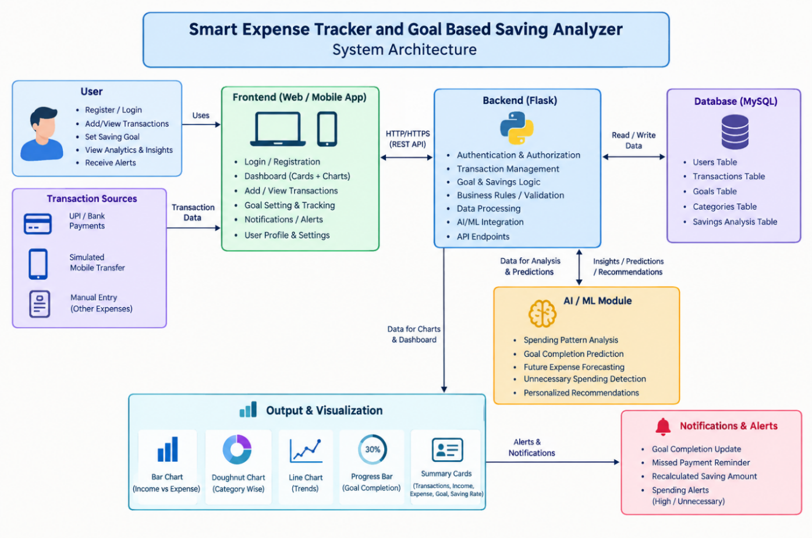
System Architecture of Smart Spend

Working Process
The system operates through the following sequence:
- The user registers and logs in to the application.
- The user enters income and expense transaction details.
- The Flask backend validates the submitted information.
- Valid transaction records are stored in the database.
- The application retrieves transaction data and calculates income, expenses, and savings.
- The financial analysis component examines available transaction history.
- The savings module calculates goal completion and the remaining amount required.
- The dashboard displays financial summaries, graphical charts, and available recommendations.
- When a savings target is missed, the application recalculates the required savings for the remaining period.
This architecture separates user interaction, transaction processing, data storage, and financial analysis, making the application easier to maintain and extend.
3.4 HARDWARE REQUIREMENTS
The hardware requirements specify the minimum computer resources needed to develop, run, and test the Smart Spend application.

S. No. | Hardware Component | Minimum Requirement | Recommended Requirement
1 | Processor | Intel Core i3 or equivalent | Intel Core i5 or equivalent
2 | RAM | 4 GB | 8 GB or higher
3 | Storage | 2 GB of available space | 5 GB or more of available space
4 | Display | Standard computer display | Full HD display
5 | Input Devices | Keyboard and mouse | Keyboard and mouse
6 | Network | Localhost access | Internet connection for installation and deployment

Description
Processor: A processor capable of running Python, Flask, the database, and a web browser is required.
RAM: At least 4 GB of RAM is sufficient for basic development and testing. A system with 8 GB or more is recommended for smoother operation.
Storage: Storage is required for application files, database records, development tools, libraries, and test datasets.
Display and Input Devices: A display, keyboard, and mouse are used to develop the application and interact with its dashboard.
Network: Internet access may be needed to install software dependencies and deploy the application. A local version can operate without a continuous internet connection once the required components are installed.
A dedicated GPU is not required for the basic application because transaction processing, financial calculations, and lightweight data analysis generally run on a standard CPU.
3.5 SOFTWARE REQUIREMENTS
The software requirements identify the programming languages, frameworks, libraries, development tools, and database technologies used to develop the Smart Spend application.
S. No. | Software Component | Technology | Purpose
1 | Operating System | Windows / Linux / macOS | Runs the application and development tools
2 | Frontend | HTML | Structures web pages
3 | Styling | CSS | Designs the user interface
4 | Client-Side Scripting | JavaScript | Supports interactive interface elements
5 | Backend Language | Python | Implements application logic and calculations
6 | Web Framework | Flask | Handles requests and connects frontend with backend
7 | Database | SQLite or MySQL | Stores user and transaction records
8 | Data Analysis | Pandas and NumPy, | Processes and analyses financial data
9 | Data Visualization | Chart.js or Matplotlib | Displays financial charts
10 | Development Environment | Visual Studio Code | Used to write and manage source code
11 | Web Browser | Google Chrome / Firefox | Runs and tests the web application

Description of Software Components
Python: Python is used to implement the application's backend operations, financial calculations, transaction processing, and analysis logic.
Flask: Flask is a lightweight Python web framework used to manage application routes, process form submissions, connect to the database, and return information to the frontend.
HTML, CSS, and JavaScript: These technologies are used to develop the registration page, login page, transaction forms, dashboard, and interactive elements.
SQLite or MySQL: The database stores user accounts, transaction information, and savings goals. SQLite is suitable for a lightweight prototype, while MySQL can be used when the application requires a separate database server.
Pandas and NumPy: These libraries can be used to process transaction datasets, calculate financial statistics, and support spending analysis.
Chart.js or Matplotlib: These tools can be used to visualize income, expenses, savings progress, and spending patterns through graphs and charts.
Visual Studio Code: This development environment is used to create, edit, debug, and organize the application's source code.
Web Browser: A modern browser allows users to access the application and view financial information through the dashboard.
The proposed software configuration supports the development of a modular personal finance management system that combines transaction recording, financial calculations, savings goal monitoring, and data-driven expense analysis

CHAPTER 4. IMPLEMENTATION

4.1 METHODOLOGY

The methodology describes the systematic approach followed to design, develop, and implement the Smart Expense Tracker and Goal-Based Savings Analyzer. The project aims to simplify personal financial management by integrating transaction recording, expense categorization, financial calculations, savings goal tracking, and data analysis into a single web-based application.
The system is developed using HTML, CSS, and JavaScript for the frontend, Python and Flask for the backend, and a database for storing user and transaction information. The methodology consists of requirement analysis, system design, database development, frontend implementation, backend development, financial analysis, system integration, and testing. Each stage contributes to developing a functional application that helps users understand their spending behaviour and monitor their savings goals.
The methodology consists of the following steps:
- Requirement Analysis: Identify the system requirements, including user registration, login, expense tracking, financial analysis, and savings goal management.
- System Design: Design the application architecture, database structure, user interface, and communication between the frontend and backend.
- User Authentication: Develop registration and login modules to allow users to access their financial information.
- Transaction Management: Implement features to record, update, and categorize income and expenses in the database.
- Financial Calculation: Calculate total income, total expenses, available balance, and savings rate using transaction data.
- Goal-Based Savings Analysis: Allow users to define savings targets and deadlines, monitor progress, and calculate the amount required to save each month.
- Expense Analysis and Prediction: Analyze historical spending records to identify spending patterns and estimate future expenses, depending on the implemented analysis method.
- Dashboard Development: Display financial summaries, charts, graphs, and savings progress indicators through an interactive dashboard.
- Testing and Evaluation: Test the application modules, verify financial calculations, check database operations, and evaluate whether the system meets its requirements.

4.2 RESEARCH APPROACH
The research approach adopted for the Smart Spend: AI-Powered Expense Tracker and Goal-Based Savings Analyzer is based on a design and development approach. The primary objective is to develop a web-based personal finance management application that helps users record income and expenses, analyse spending patterns, and achieve financial goals. The approach involves identifying the limitations of traditional expense-tracking methods, defining system requirements, designing the application architecture, implementing the required modules, and evaluating the system through functional testing.
The proposed system uses HTML, CSS, and JavaScript for the frontend, Python and Flask for backend processing, and a database to store user information, transaction records, and savings goals.
- Data Collection: Collects user-entered income, expenses, transaction details, and savings goals to maintain financial records.
- Data Analysis: Analyzes transaction records to calculate spending patterns, savings rates, and monthly financial performance.
- Predictive Analysis: Uses historical expense data to estimate future spending and support better budget planning, depending on the implemented prediction method.
- Performance Evaluation: Evaluates the system by testing transaction management, calculation accuracy, savings goal tracking, and dashboard functionality.

4.3 IMPLEMENTATION
The Smart Expense Tracker and Goal-Based Saving Analyzer is implemented as a web-based application using Python, Flask, MySQL, HTML, CSS, JavaScript, and AI/ML techniques. The system is developed to manage financial transactions, analyze spending behavior, and help users achieve their savings goals through intelligent recommendations.
1. User Authentication Module
This module allows users to register and log in to the application using their credentials. User information is stored in the MySQL database, enabling the system to manage individual user accounts and provide access to personalized financial information.
2. Transaction Management Module
This module enables users to add, view, and manage income and expense transactions. Transactions are categorized into different types, such as food, transportation, shopping, education, and other expenses. The application processes transaction details and stores them in the database for further analysis.
3. Expense Analysis Module
The expense analysis module calculates total income, total expenses, and savings based on the recorded transactions. It generates category-wise spending summaries and monthly financial reports, helping users understand their spending habits and identify areas where expenses can be reduced.
4. Goal-Based Saving Module
This module allows users to set a financial goal, specify the target amount, and define the expected completion period. The system calculates the required monthly savings and tracks progress toward the target. If the user falls behind the planned savings schedule, the application recalculates the required savings amount for the remaining period.
5. AI/ML Analysis Module
The AI/ML module analyzes available transaction data to identify spending patterns and estimate future expenses. Based on historical financial information, the system can identify potentially unnecessary spending and provide personalized recommendations to improve savings. The accuracy of predictions depends on the availability and quality of transaction data.
6. Dashboard and Visualization Module
The dashboard displays important financial information through summary cards, bar charts, doughnut charts, line charts, and savings progress indicators. These visualizations help users compare income and expenses, understand category-wise spending, monitor monthly trends, and evaluate progress toward financial goals.
7. Notification and Alert Module
This module provides alerts related to savings progress, excessive spending, missed savings targets, and changes in the required savings amount. These notifications help users stay informed about their financial activities and take appropriate action to achieve their goals.
8. Database Management Module
MySQL is used to store and manage user details, transaction records, expense categories, savings goals, and analysis results. The Flask backend communicates with the database to retrieve, update, and store information whenever users interact with the application.

Overall Implementation
The implementation integrates all the modules into a single application. Users enter their financial information through the web interface, the Flask backend validates and processes the data, and MySQL stores the records. The analysis module uses the available data to generate financial insights, while the dashboard presents the results through graphical visualizations and notifications. This integrated approach supports efficient expense tracking, informed financial decisions, and systematic savings management.

CHAPTER 5. CONCLUSION AND FUTURE WORK

5.1 CONCLUSION

The Smart Expense Tracker and Goal-Based Savings Analyzer is designed to simplify personal financial management by integrating income and expense tracking, transaction categorization, financial analysis, and goal-based savings into a single web-based application. The system helps users monitor their spending habits, calculate savings, and visualize their financial status through an interactive dashboard. It also supports savings goal tracking by displaying progress and calculating the remaining amount required to achieve financial targets.
The application uses HTML, CSS, and JavaScript for the frontend, Python and Flask for the backend, and a database to store financial records. By automating financial calculations and analysing available transaction data, the system aims to improve financial awareness and support better budgeting decisions. Future enhancements, such as advanced machine learning models, automatic transaction integration, and mobile application support, can further improve its functionality. Overall, Smart Spend provides a practical approach to personal finance management and encourages users to develop better spending and saving habits.

5.2 Purpose and Achievements

Expense Management: To provide a centralized platform for recording, tracking, and categorizing daily income and expenses.
- Savings Goal Planning: To help users set financial goals, define target amounts, and monitor savings progress within a specified period.
- Financial Analysis: To analyze spending patterns, calculate savings rates, and identify unnecessary expenses.
- Expense Prediction: To estimate future expenses using historical transaction data and support better budget planning.
- Smart Savings Recommendations: To calculate the required monthly savings amount when users fall behind their planned savings targets.
- Visual Financial Monitoring: To display financial summaries, charts, and progress indicators for easy understanding of financial status.
ACHIEVEMENTS OF THE SYSTEM
- User Account Management: Provides login and registration features for accessing personal financial information.
- Transaction Tracking: Enables users to record and manage income and expense transactions.
- Automated Calculations: Calculates total income, total expenses, available balance, and savings rate from recorded transactions.
- Savings Progress Tracking: Displays the percentage of completion for user-defined savings goals.
- Spending Pattern Analysis: Helps users understand their spending habits through categorized expense summaries.
- Financial Dashboard: Presents important financial information through a centralized dashboard with visual representations.
- Budget Planning Support: Helps users plan monthly budgets and estimate future financial requirements.
- Improved Financial Awareness: Supports informed spending decisions and encourages consistent saving habits.

Significance of the System
- Improved Financial Management: Helps users monitor their income, expenses, and savings in one place, enabling better control over their personal finances.
- Better Spending Awareness: Categorizes expenses and identifies spending patterns, helping users understand where their money is being spent.
- Goal-Oriented Savings: Enables users to set financial goals, define target amounts, and track their savings progress over a specified period.
- Intelligent Financial Planning: Analyses previous spending records to provide useful insights and recommendations for managing monthly budgets effectively.
- Expense Prediction: Estimates future expenses based on historical transaction data, helping users prepare for upcoming financial needs.
- Automatic Savings Adjustment: Calculates the required savings amount for the remaining months when users fall behind their savings targets.
- Visual Financial Insights: Presents financial information through charts, graphs, and progress indicators, making it easier to understand financial performance.
- Encourages Saving Habits: Promotes disciplined spending and regular saving by providing progress updates and highlighting opportunities to improve savings.

5.3 TECHNICAL HIGHLIGHTS

Web-Based Application: Developed as a web application using Flask to provide an interactive and user-friendly interface for managing personal finances.

Database Management: Uses an SQL database to securely store user details, income, expenses, transaction history, and savings goals.

User Authentication: Provides login and registration functionality to manage individual user accounts.

Expense Categorization: Organizes transactions into categories such as food, travel, education, shopping, and bills for better spending analysis.

Automated Financial Calculations: Calculates total income, total expenses, available balance, savings amount, and savings rate based on recorded transactions.

AI-Based Expense Analysis: Analyses historical spending data to identify spending patterns and provide personalized financial recommendations.

Goal-Based Savings Analysis: Allows users to set savings targets and deadlines, tracks savings progress, and displays the percentage of goal completion.

Expense Prediction: Uses historical transaction data to estimate future expenses and help users plan their monthly budgets.

Interactive Dashboard: Displays financial summaries, charts, graphs, and savings progress indicators for easy understanding of financial status.

Dynamic Savings Recommendations: Recalculates the required monthly savings amount when users fall behind their planned savings schedule.

EVALUATION AND RESULTS

1. Evaluation

The Smart Spend application is evaluated to verify its functionality, accuracy, and usability in managing personal financial information. The evaluation focuses on user registration and login, transaction management, database operations, financial calculations, savings goal tracking, and dashboard visualization. Each module is tested to ensure that it performs its intended function correctly.

The transaction management module is evaluated by entering income and expense records and verifying whether the information is stored and retrieved correctly. Financial calculations are checked by comparing the application's results with manually calculated values. The savings goal module is tested to verify progress percentages, remaining savings amounts, and the recalculation of required savings when a user falls behind the planned target.

The dashboard is also evaluated to ensure that financial summaries and graphical representations correspond to the stored transaction data.

2. Results

The expected outcome of the Smart Spend application is a functional web-based platform that simplifies personal financial management. The application provides a centralized dashboard for viewing income, expenses, savings, and transaction history.

It calculates financial summaries automatically and allows users to establish savings goals and monitor their progress through graphical indicators.

The financial analysis component can help users identify spending patterns and recurring expenses from available transaction records. If expense forecasting and recommendation features are implemented, they can provide additional insights to support budgeting decisions. Overall, the system aims to reduce manual calculations, improve financial awareness, and help users manage their savings goals more effectively.

3. Functional Testing Results

S. No. | Module | Test Performed | Expected Result
1 | User Registration | Enter valid registration details | User account is created successfully
2 | User Login | Enter valid login credentials | User accesses the dashboard
3 | Transaction Management | Add an income or expense | Transaction is stored in the database
4 | Financial Calculation | Calculate total income and expenses | Correct totals are displayed
5 | Savings Analysis | Calculate savings and savings rate | Correct values are displayed
6 | Goal Tracking | Set a savings target | Goal progress is displayed
7 | Dashboard Visualization | View financial charts | Charts represent the available transaction data
8 | Database Operations | Retrieve saved transactions | Stored records are displayed correctly

Overall Outcome

The Smart Spend project demonstrates an approach to integrating transaction management, financial calculations, and goal-based savings tracking into a single application. Its dashboard and financial summaries help users understand their spending behaviour, while savings progress indicators support financial planning. The system can be extended with more advanced forecasting techniques and automated transaction integration to provide additional functionality in future versions.

5.4 RESULTS

OUTPUT:

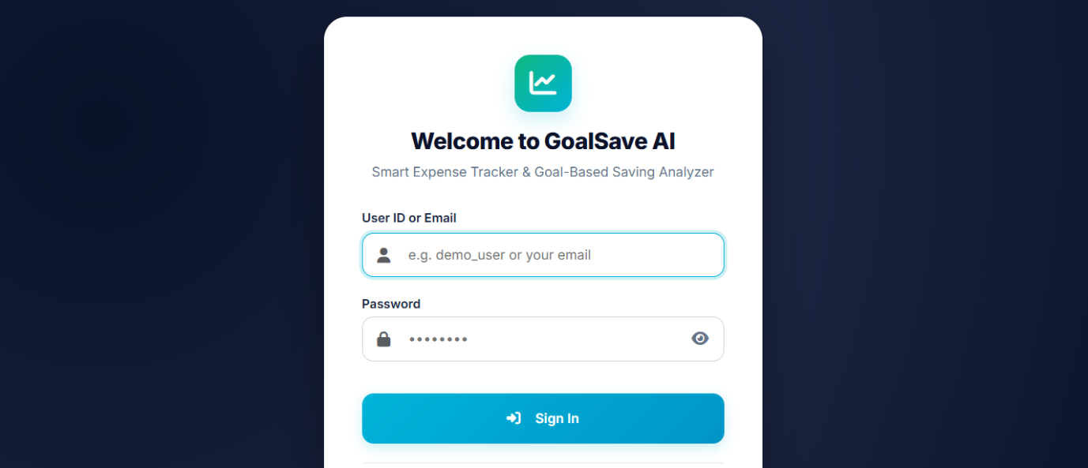
Fig-1 Login Page

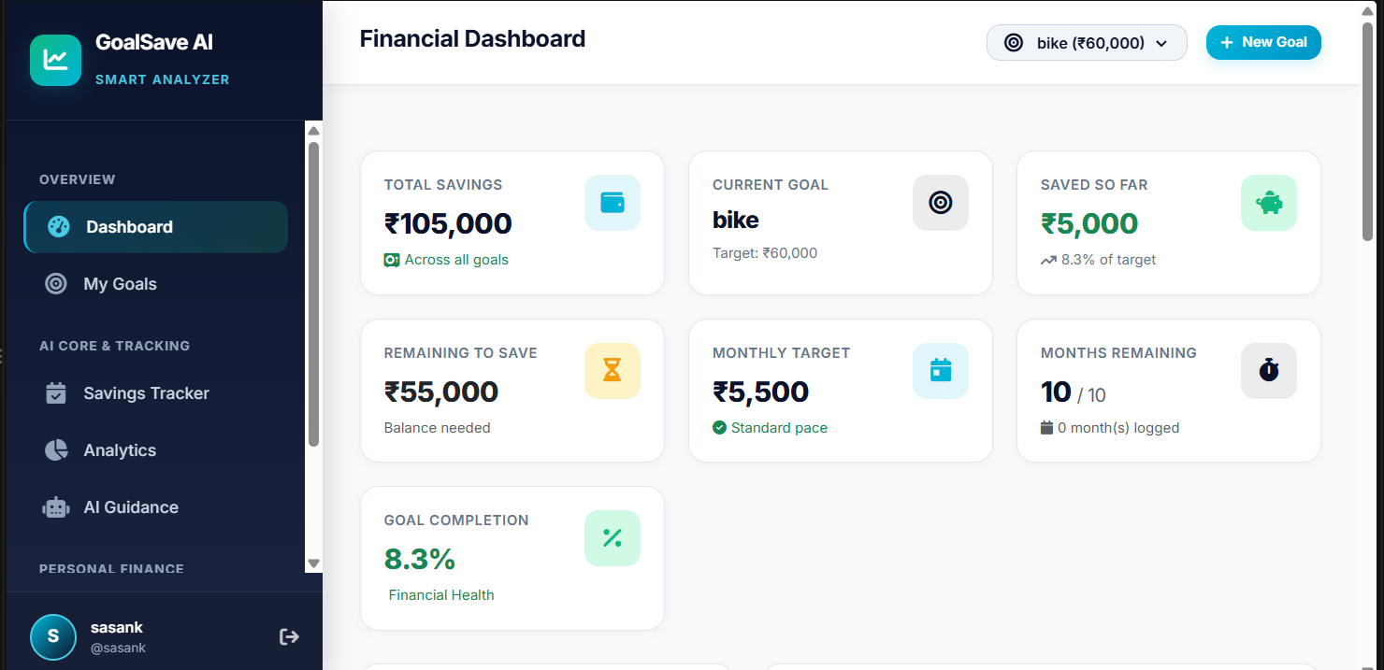
Fig-2 Dashboard
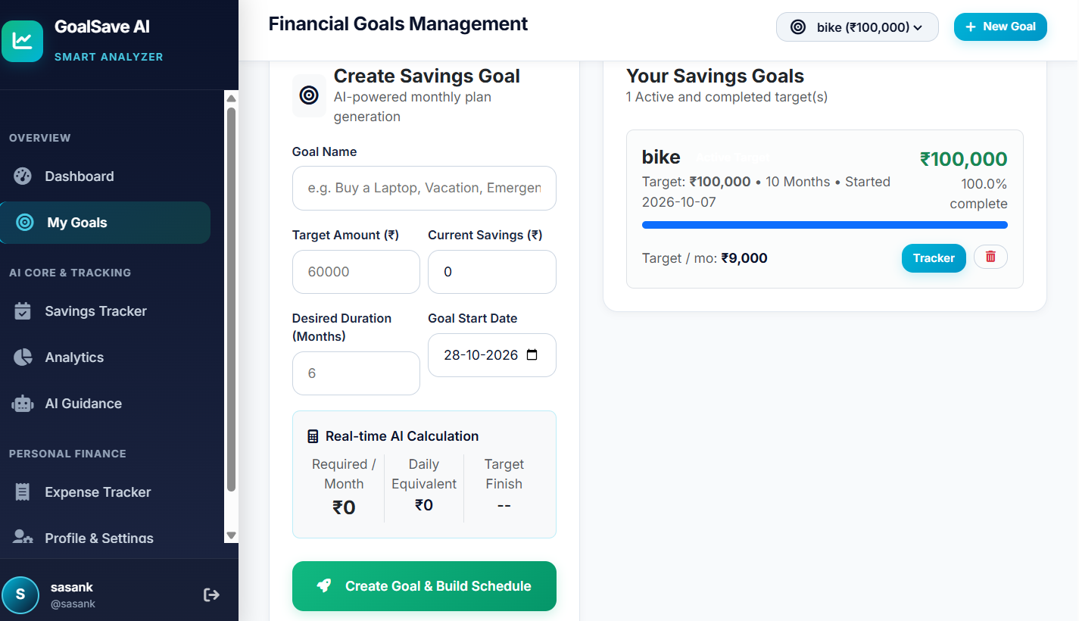

Fig-3 Financial Goals Management

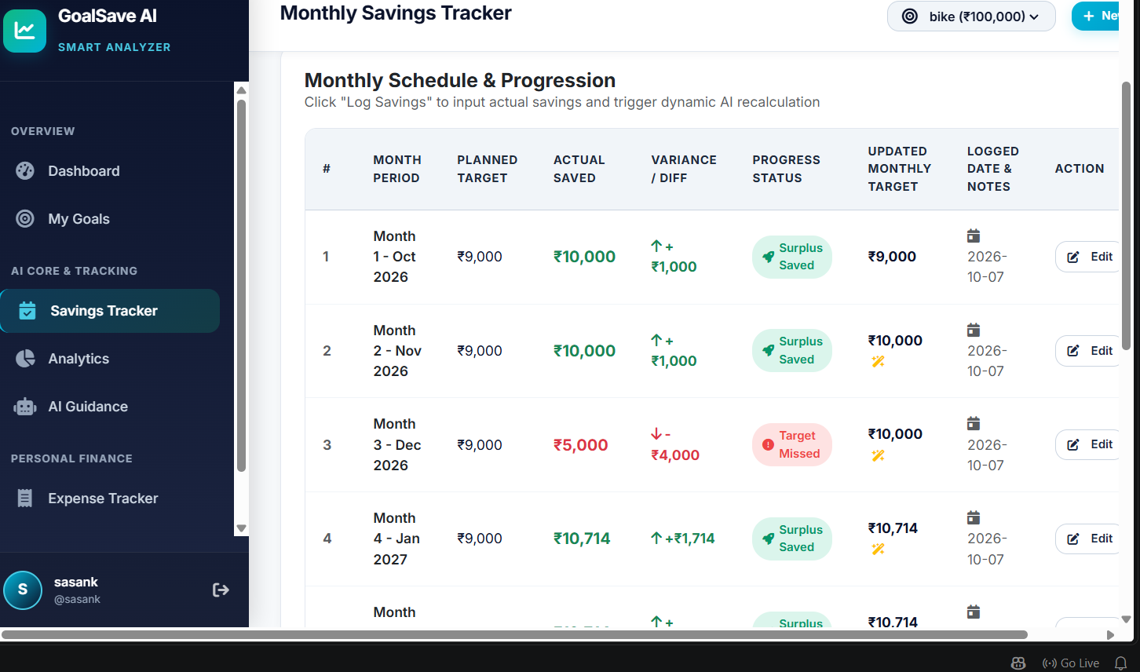

Fig-4 Monthly Savings Tracker

REFERENCES:

- Uyanahewa, M. I. R., Jayawardana, G. V. H. D., Bandara, M. B. D. N., Hapugala, H. A. V. V., Attanayaka, B., and Nawinna, D. (2023). “WONGA: The Future of Personal Finance Management – A Machine Learning-Driven Approach for Predictive Analysis and Efficient Expense Tracking.” 2023 4th International Conference for Emerging Technology (INCET). DOI: 10.1109/INCET57972.2023.10170209.
- Lingayat, L., Yadav, N., Rathod, P., Durutkar, P., and Ghode, S. (2024). “Design and Implement of Real Time Expense Tracker Using ML.” Proceedings of the International Conference on Innovative Computing & Communication (ICICC 2024).
- Mahto, B., Varma, A. K., Kumari, S., Parveen, R., Firdous, C., Sharma, A., and Amrendra, K. (2025). “Smart Pocket: A Machine Learning-Based Expense Tracker and Spending Predictor.” International Journal of Research and Innovation in Applied Science, 10(11), 352–362. DOI: 10.51584/IJRIAS.2025.101100032.
- Tai, L. W., Poh, L. Z., and Hossen, M. I. (2026). “Designing a Predictive Expense Tracking Mobile Application: A Comparison of Random Forest, Linear Regression, and Prophet-Based Models.” Journal of Informatics and Web Engineering, 5(3), 252–265. DOI: 10.33093/jiwe.2026.5.3.16.
- “Expense Radar: An AI-Driven Budget Management System.” (2025). 2025 International Conference on Computer and Applications (ICCA). IEEE. DOI: 10.1109/ICCA66035.2025.11430733.
- “An Intelligent Personal Finance Management System With Automated Financial Data Processing and Machine Learning-Based Budget Forecasting.” (2026). International Journal of Latest Research in Publication and Research (IJLRP).
- “Finance Tracker: A Personal Expense Management.” (2026). Innovation and Integrative Research Center Journal, 4(5), 501–511.
- “Finalyze: An AI Powered Expense Tracker for Smart Financial Management.” (2026). International Journal of Creative Research Thoughts (IJCRT), 14(3), i988–i996.

